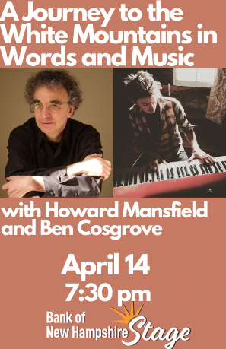

Capitol Center for the Arts
Concord, NH

Tickets:
Box office: 603-225-1111
Online: https://ccanh.secure.force.com/ticket/#/events/a0S1R00000Cc8NzUAJ

